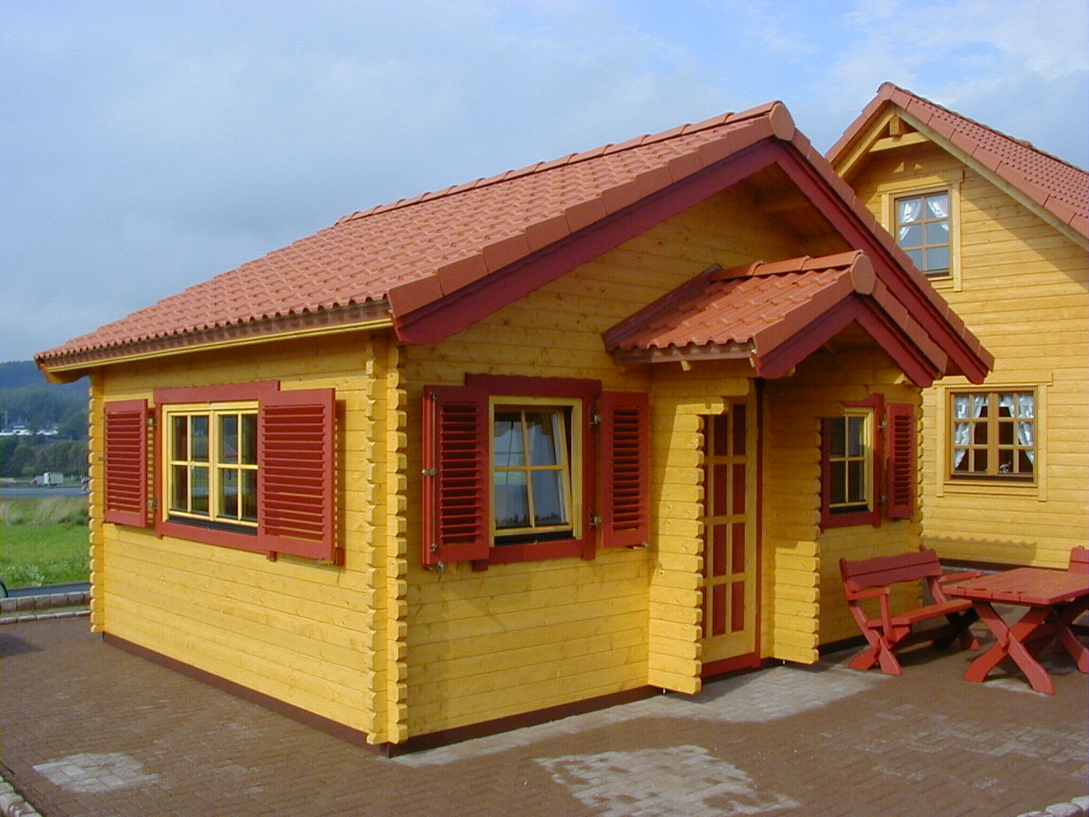 | 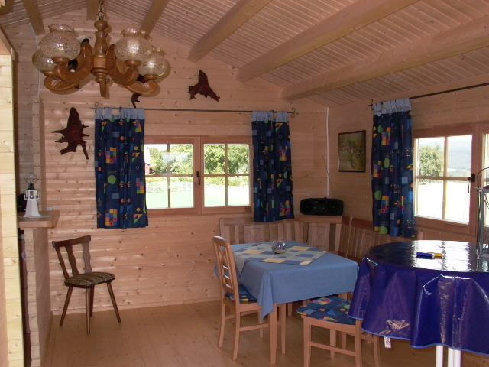
 | 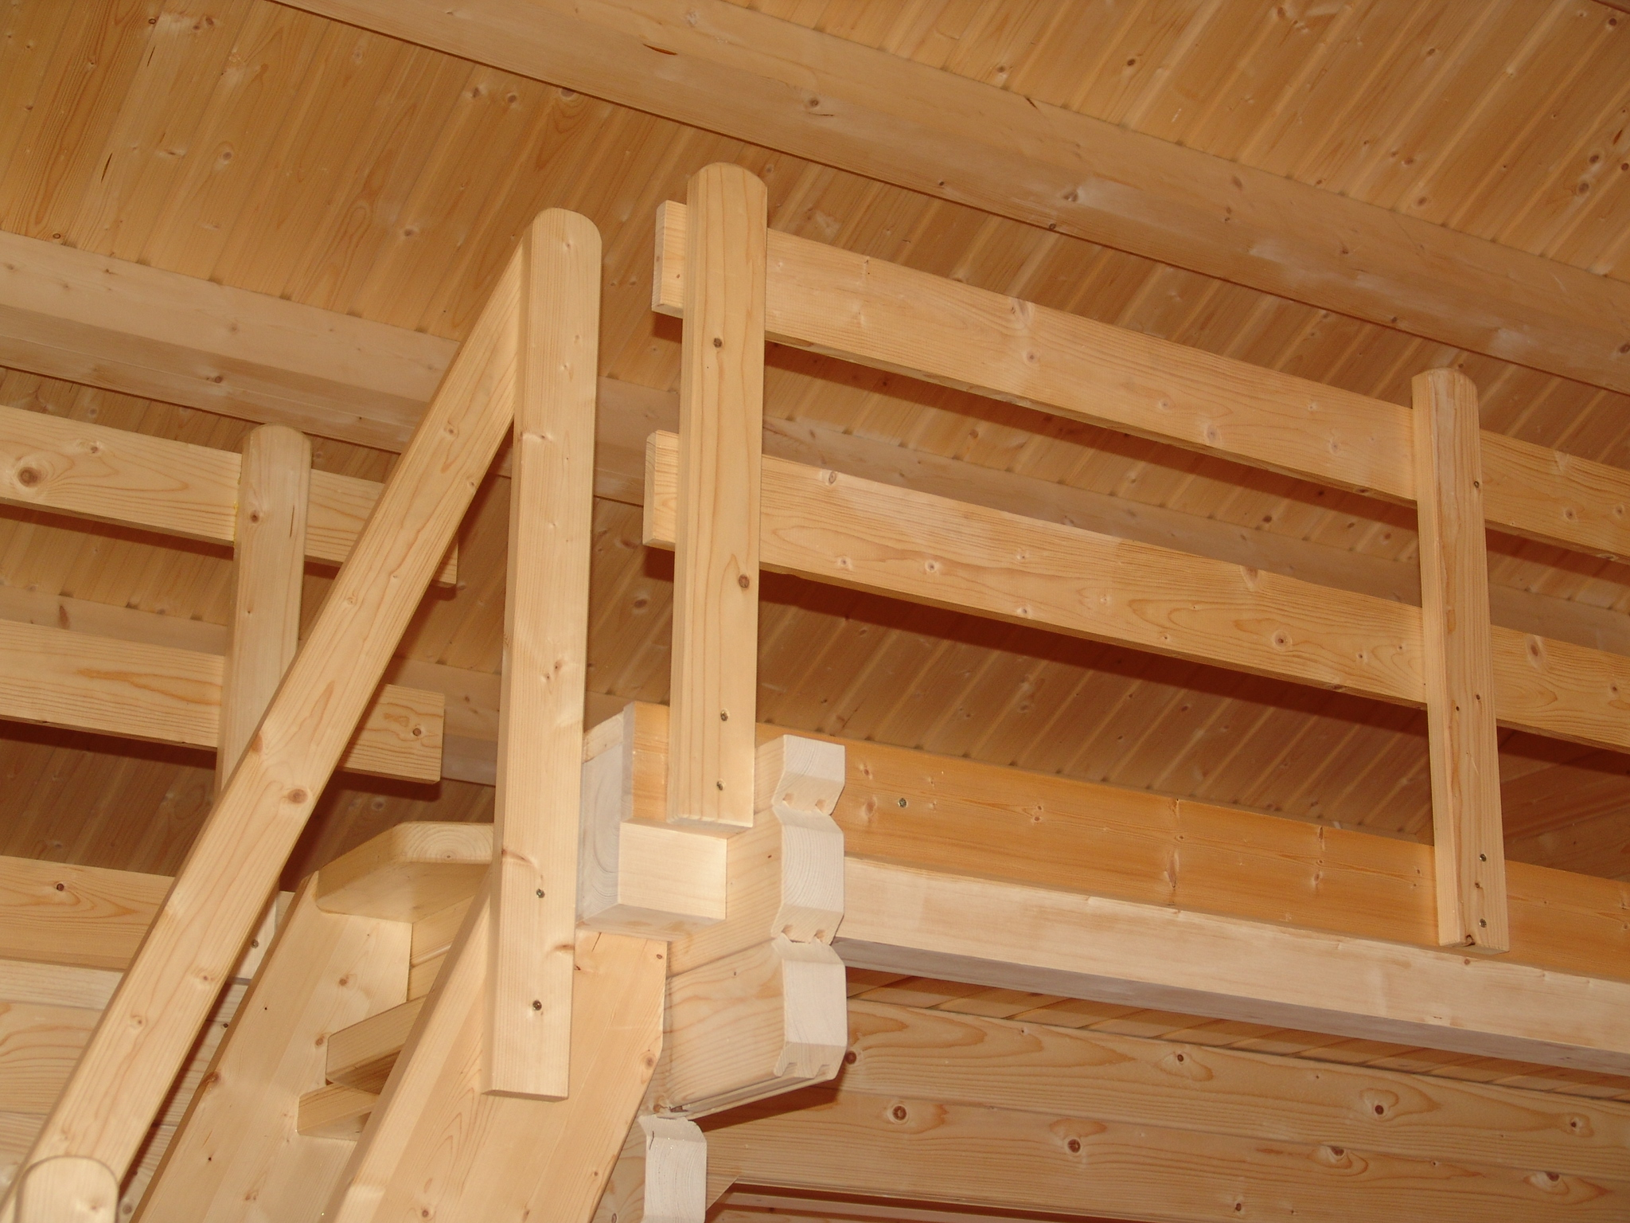

Laura 5.5 m x 4.3 m

Roof projection: Front 0.50 m
Back 0.50 m
Side 0.30 m

Prices:

45mm: £ 7,162
60 mm: £ 8,378
95 mm: £ 11,282

Consisting of:

Walls: from 45 mm (glued 60 and 95 mm) double tongue and groove logs
Floor EEC: from 20 mm of plane halls on impregnated camp woods
Second floor: from 28 mm of combination halls on glued bars
Height: 2.34 m to eves, 3.84m to ridge
Roof: from 20 mm tongue and groove boards on glued purlins
Door: 1 unit 90/196 with seal
1 unit 70/196 with seal
Window: 1 double-glazed 170/94 with seal and rungs
4 double-glazed 80/94 with seal and rungs
Stairs: Space saving stairs with railing.

Extras:

Roof Tiles Call for price
Shutters Call for price
Floor and roof isolation Call for price

